Big Data Analysis with IBM Cloud Databases

# PHASE 3

Start building the big data analysis solution using IBM

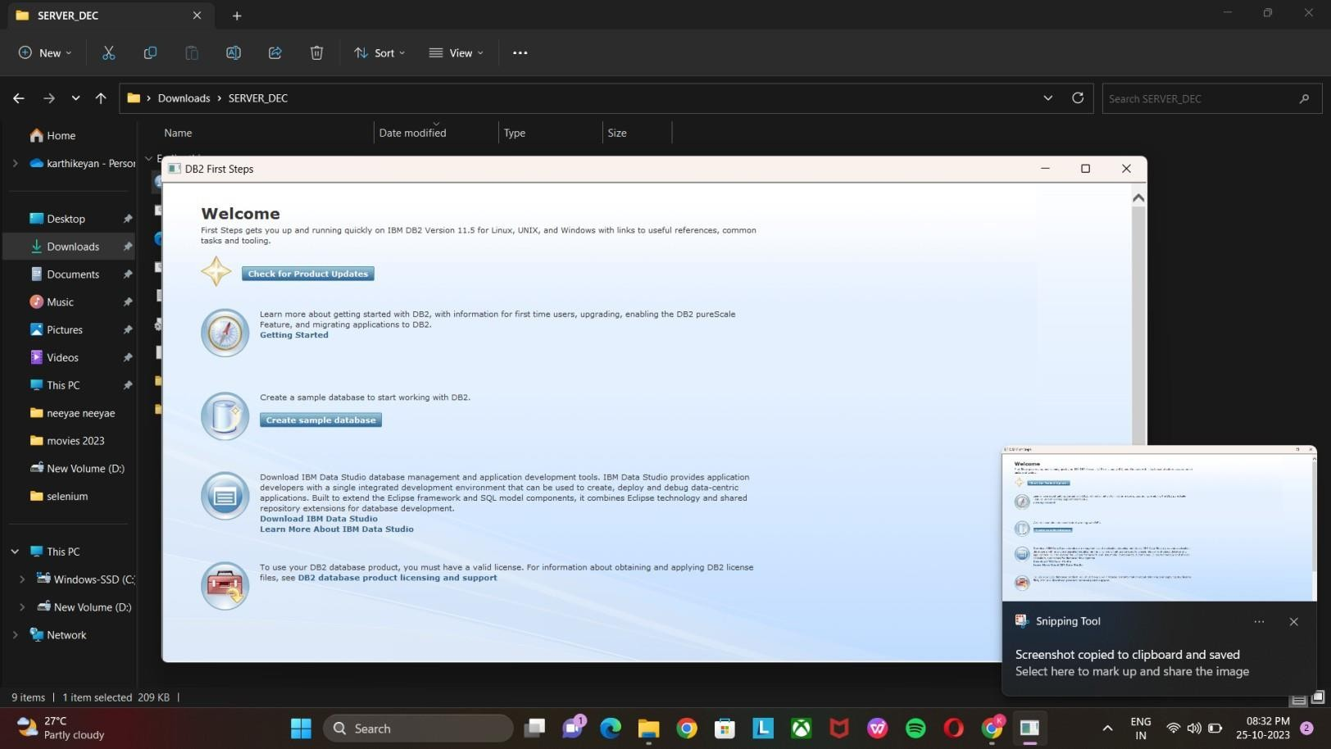

Cloud Databases.

->In the frst step created the sample database in DB2.

->Provisiong a db2 data analysis instance ,and confg the necessary security setting.

->The table were created in specifc data requirement.

# **PERFORM BASIC DATA CLEANING AND TRANSFORMATION:**

->Develop queries or scripts to explore and analyze the selected dataset.

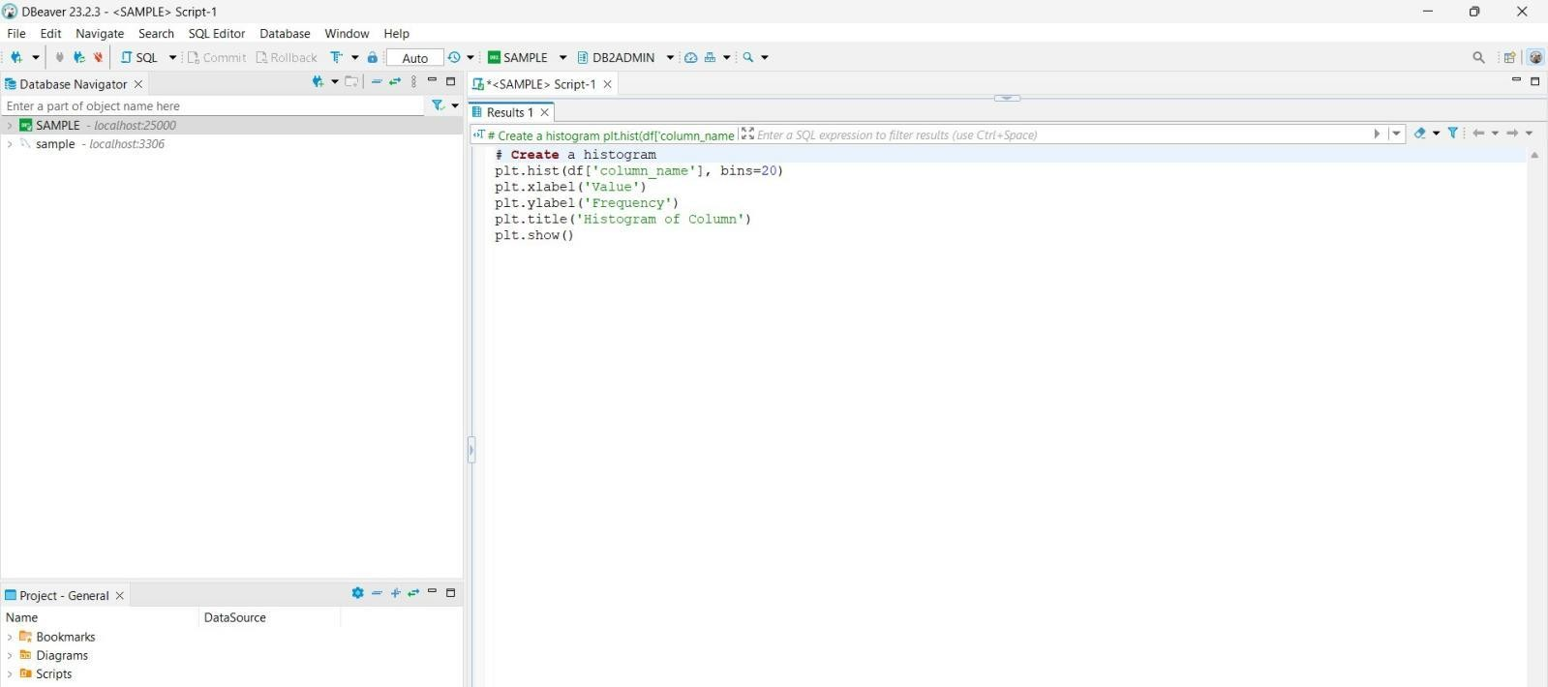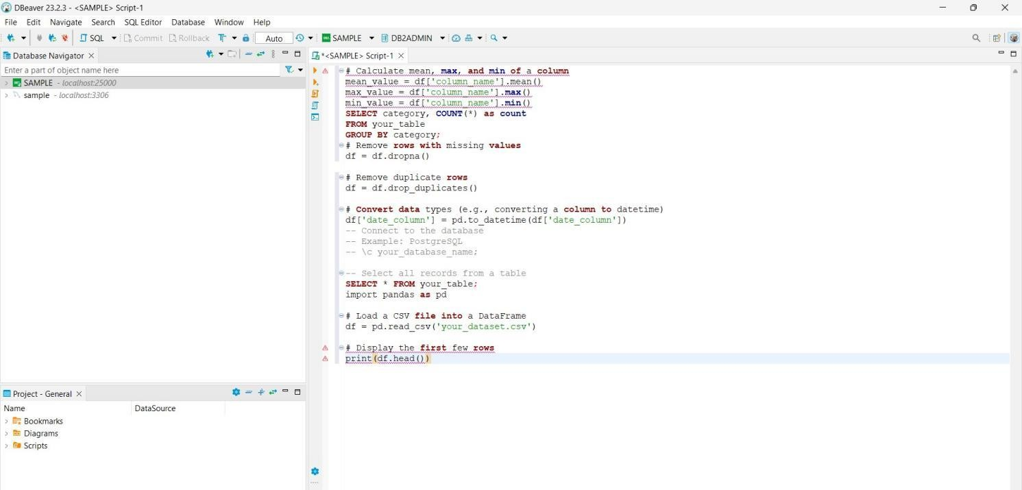

**Data source code:**

SELECT *

FROM your_table LIMIT 5;

SELECT COUNT(*) AS missing_count FROM your_table

WHERE column_name IS NULL;

import pandas as pd

df = pd.read_csv('your_dataset.csv')

print(df.head ())

